NORTH CHARLESTON PERFORMING ARTS CENTER GROUP SALES ORDER FORM

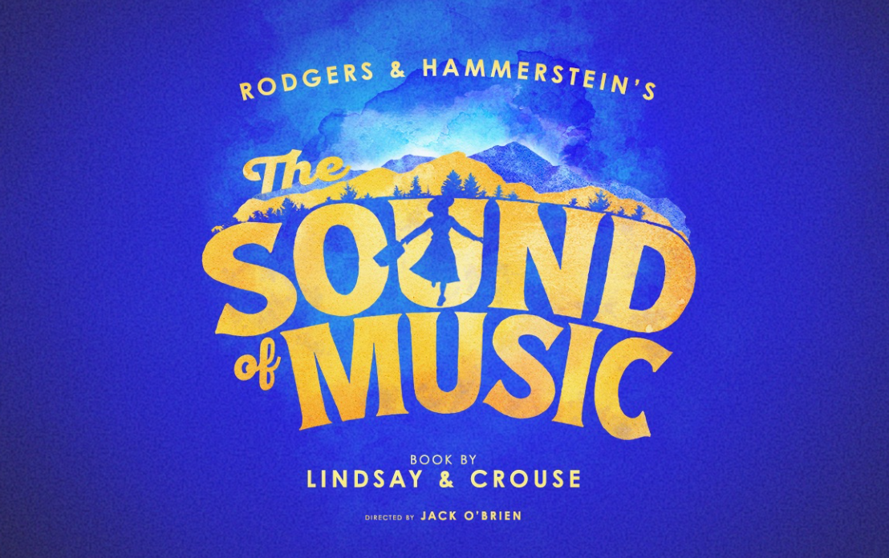

November 4-9, 2025 GROUPS 10+ AVAILABLE NOW!
DATE | TIME | PRICE LEVEL 1* | PRICE LEVEL 2* | PRICE LEVEL 3*
Tuesday, Nov. 4 | 7:30PM | $85.22 | $66.32 | $47.42
Wednesday, Nov. 5 | 7:30PM | $85.22 | $66.32 | $47.42
Thursday, Nov. 6 | 7:30PM | $85.22 | $66.32 | $47.42
Friday, Nov. 7 | 7:30PM | $94.67 | $75.77 | $56.87
Saturday, Nov. 8 | 2:00PM | $104.85 | $83.85 | $62.85
Saturday, Nov. 8 | 7:30PM | $94.67 | $75.77 | $56.87
Sunday, Nov. 9 | 1:00PM | $104.85 | $83.85 | $62.85
Sunday, Nov. 9 | 6:30PM | $85.22 | $66.32 | $47.42
 |  | 40+ Groups | Pricing Below
Tuesday, Nov. 4 | 7:30PM | $80.65 | $62.80 | $44.95
Wednesday, Nov. 5 | 7:30PM | $80.65 | $62.80 | $44.95
Thursday, Nov. 6 | 7:30PM | $80.65 | $62.80 | $44.95
Friday, Nov. 7 | 7:30PM | $89.57 | $71.72 | $53.87
Saturday, Nov. 8 | 2:00PM | $104.85 | $83.85 | $62.85
Saturday, Nov. 8 | 7:30PM | $89.57 | $71.72 | $53.87
Sunday, Nov. 9 | 1:00PM | $104.85 | $83.85 | $62.85
Sunday, Nov. 9 | 6:30PM | $80.65 | $62.80 | $44.95

*PRICES ARE DYNAMIC AND CAN CHANGE.
Please fill out the information below and we will contact you to complete your order!
Name: _______________________________________________________________________________________________
Address: _____________________________________________________________________________________________
City/State/Zip: ________________________________________________________________________________________
Day Phone: ___________________________________________________________________________________________
Email: _______________________________________________________________________________________________
Select your top two (2) Performance Date/Time and Price Level:
1. _________________________ $ ____________________ # Seats__________
2. _________________________ $ ____________________ # Seats__________

Pre-sale group seating will be held in reserve for 48 hours. ALL SALES FINAL. No refunds. Dates, times, prices, and cast subject to change without notice. Group policies apply to parties of 10 or more. Ticket prices include $3 facility fee. Group discount and policies are subject to change and may be revoked without notice. Offer not valid on prior purchased tickets and may not be combined with any other offer.
Questions? Email us at groups@northcharlestoncoliseumpac.com

