Account Manager Guide – Transferring Tickets
To log into your account and update your information, follow these steps:
- Sign in here: https://am.ticketmaster.com/nccpac/.
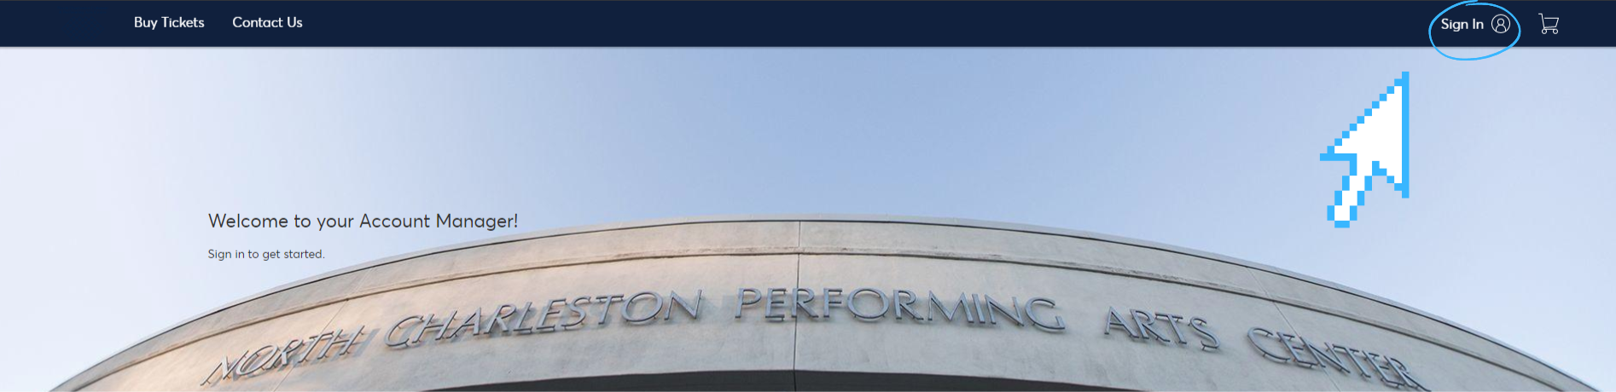

- Note: an account has been created for you with the email you provided us. If you’ve forgotten your password, you can reset it here. Within a few minutes, you will receive an email with a link to create a new password. Set your password, then use this and your email address to log in to your account.
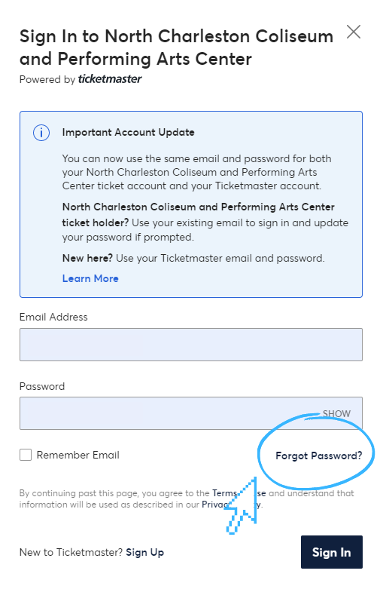

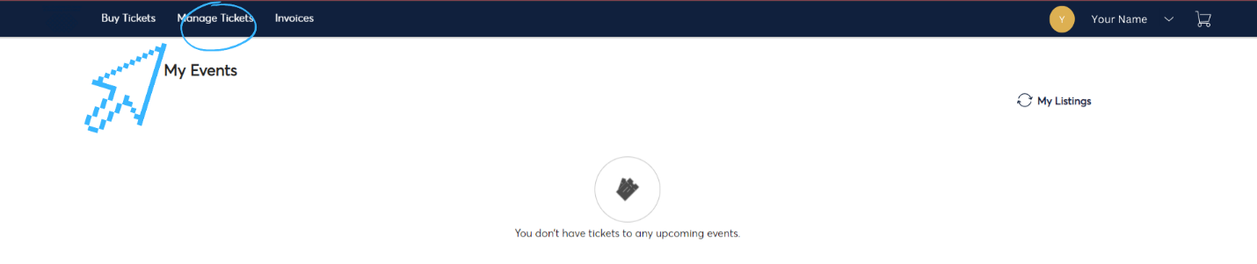
- Select “Manage Tickets” in the top left hand corner to view the tickets you currently own. You can view your tickets by clicking on the individual seats. Note: Barcodes will only show on a mobile device, so to use your tickets you must either access your tickets via your phone, or add them to your Apple Wallet.

- Select the event you would like to transfer.

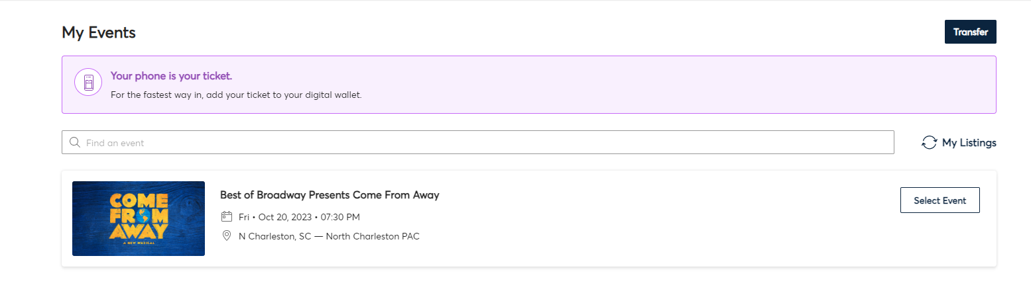
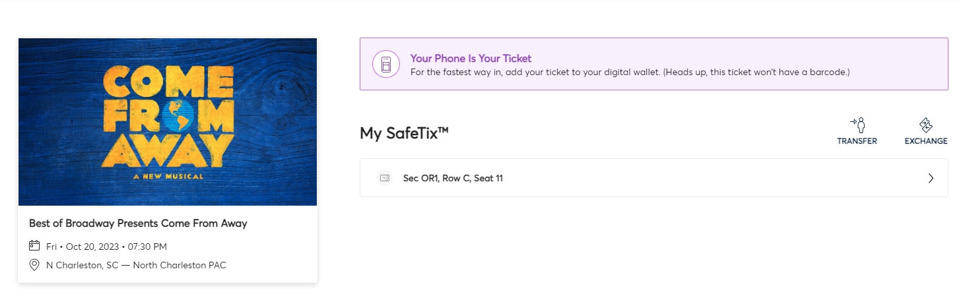
- Click “Transfer”.

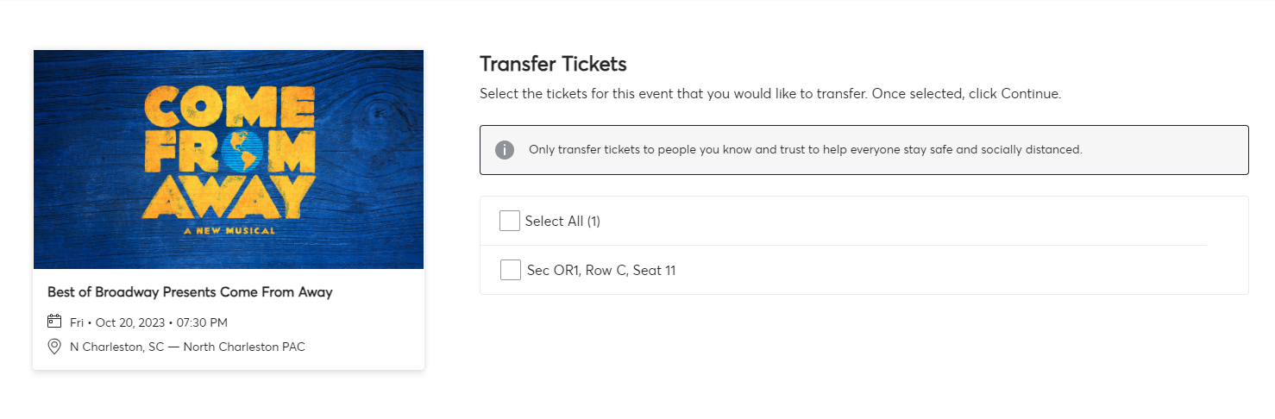
- Click “Select All” if you are wanting to transfer all of the tickets, or click the box next to each ticket you are wanting to transfer individual tickets. Then click “Continue” on the bottom right corner of your screen.
- Fill in the information below of the person you are transferring the ticket(s) to. Once you have completed the information, click “Transfer”. Please note that the person you are transferring the tickets to will receive an email with a link to accept the tickets. They MUST accept the tickets into their account in order for the tickets to be valid. Once a ticket transfer is accepted, that account becomes the new owner of the tickets and a transfer cannot be reversed.
