Account Manager Guide – How to Exchange Tickets
To log into your account and update your information, follow these steps:
- Sign in here: https://am.ticketmaster.com/nccpac/.
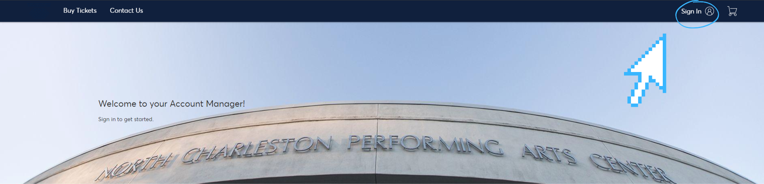

- Note: an account has been created for you with the email you provided us. If you’ve forgotten your password, you can reset it here. Within a few minutes, you will receive an email with a link to create a new password. Set your password, then use this and your email address to log in to your account.
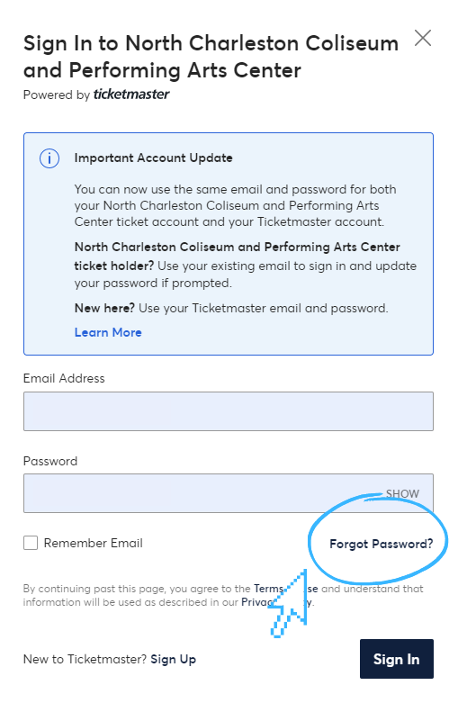

- Select “Manage Tickets” in the top left hand corner to view the tickets you currently own. You can view your tickets by clicking on the individual seats. Note: Barcodes will only show on a mobile device, so to use your tickets you must either access your tickets via your phone, or add them to your Apple Wallet.
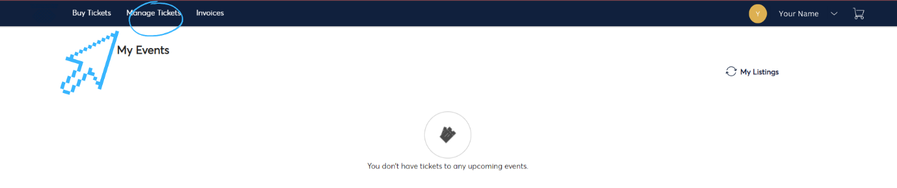

- Select the event you’d like to exchange your tickets for.
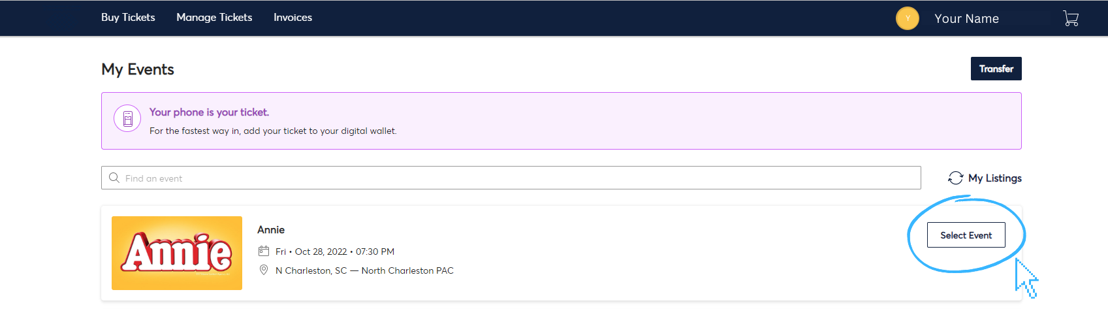
- Click “Exchange”.
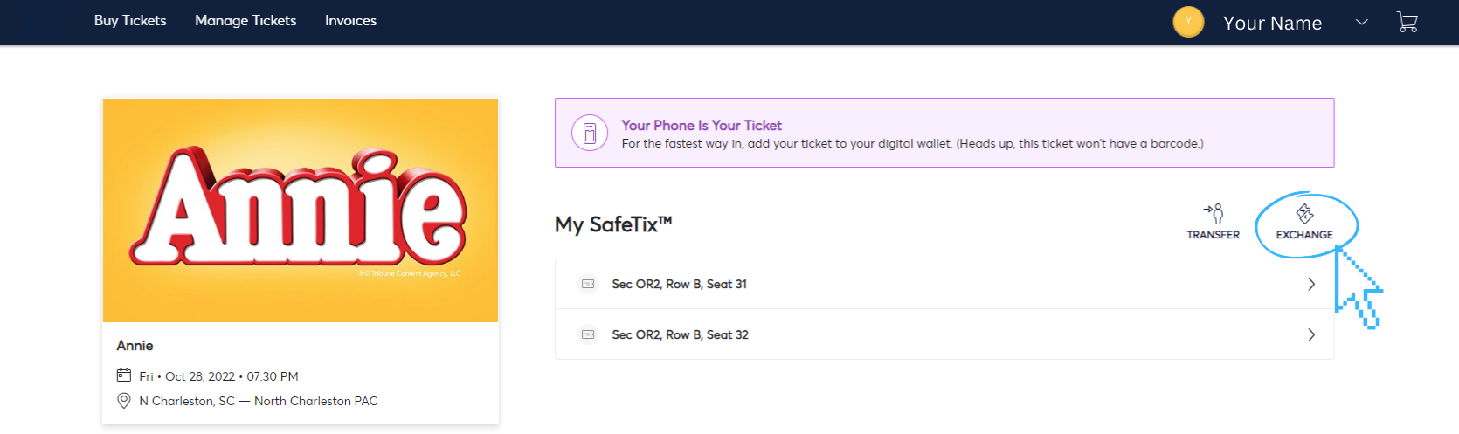

- Click “Select All” to exchange all your seats for that event. You can also select seats individually.
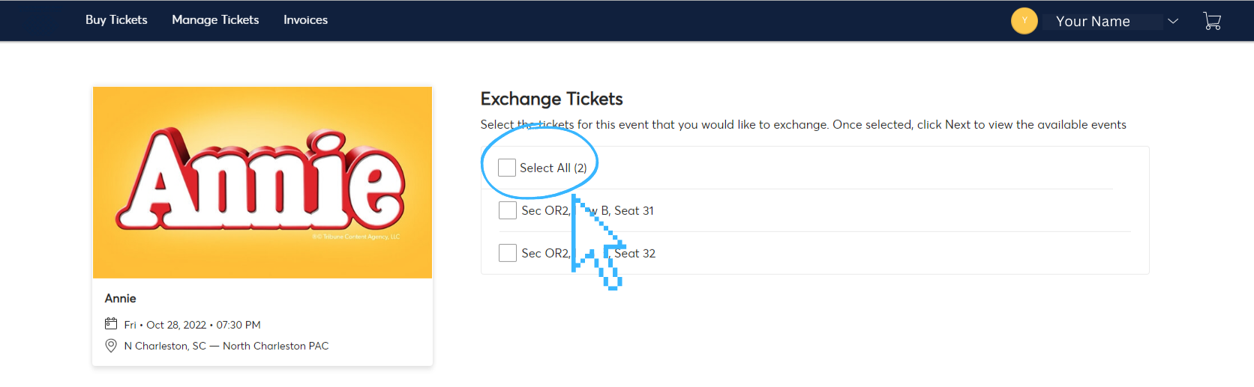
- Follow the prompts to select your desired performance time and new seat location.

